Zhenming (Mark) Yang

Prof. Z

Embedded System

14 September 2023



|  |  |  |  |
| --- | --- | --- | --- |
| Input 1 (x) | Input 2 (y) | Selector (s) | Output (o) |
| 0 | 0 | 0 | 0 |
| 1 | 0 | 0 | 1 |
| 0 | 1 | 1 | 0 |
| 0 | 1 | 0 | 0 |
| 0 | 1 | 1 | 1 |
| 1 | 1 | 1 | 1 |

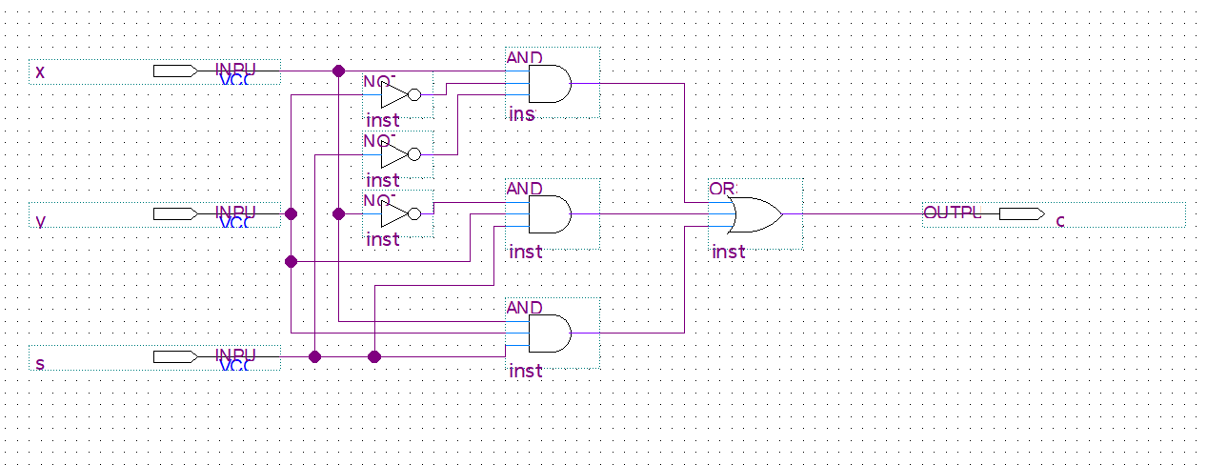

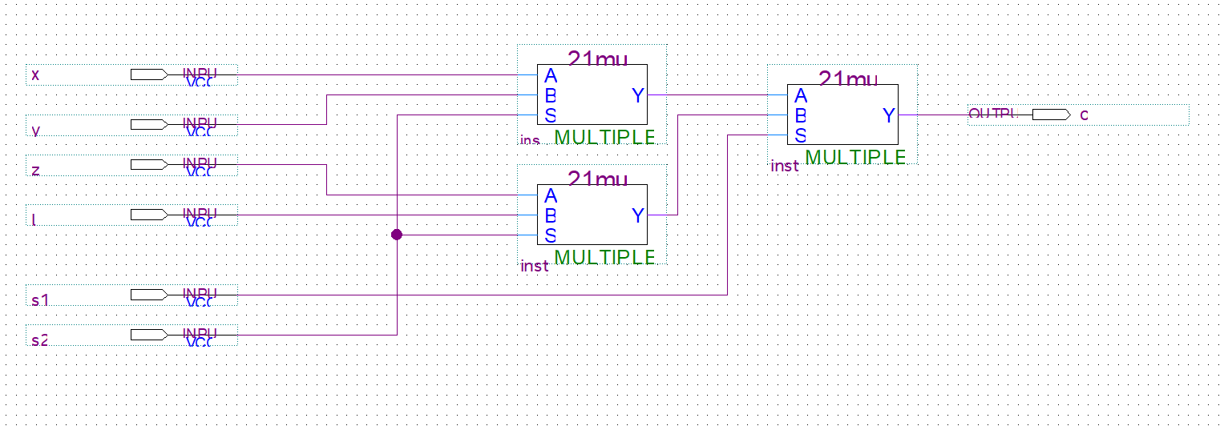

1. 1. 1037 = 0x40D
   2. 0o7125 = 3669
   3. 10011101
2. 1. Smallest:

Largest:

* 1. Smallest:

Largest:

* 1. Unsigned, because the total number unsigned numbers can represent is $2^{n}$ whereas the other two number systems can only store $2^{n}-1$. This is because unsigned numbers don’t need to worry about signs and storing that information needs some space in the bits.

1. 1. Out = AC+A’B’

|  |  |  |  |  |
| --- | --- | --- | --- | --- |
|  | (0, 0) | (0, 1) | (1, 1) | (1, 0) |
| 0 | x | 1 | 0 | 0 |
| 1 | 0 | x | 1 | 0 |

* 1. Out = (A+B+C)′+(ABC′)+B′C = (A’B’C’)+(ABC′)+B′C = A’B’+B’C+ABC’

|  |  |  |  |  |
| --- | --- | --- | --- | --- |
|  | (0, 0) | (0, 1) | (1, 1) | (1, 0) |
| 0 | 1 | 1 | 0 | 0 |
| 1 | 0 | 1 | 0 | 1 |

* 1. Out = A′BCE′+A′CE′+AC′D+AE+DE = DE+AE+A’CE’+AC’D

|  |  |  |  |  |
| --- | --- | --- | --- | --- |
|  | (0, 0) | (0, 1) | (1, 1) | (1, 0) |
| (0, 0, 0) | 0 | 0 | 0 | 0 |
| (0, 0, 1) | 0 | 0 | 1 | 1 |
| (0, 1, 1) | 1 | 1 | 1 | 1 |
| (0, 1, 0) | 0 | 0 | 1 | 1 |
|  | | | | |
| (1, 0, 0) | 1 | 1 | 0 | 0 |
| (1, 0, 1) | 0 | 0 | 1 | 1 |
| (1, 1, 1) | 1 | 1 | 1 | 1 |
| (1, 1, 0) | 1 | 1 | 0 | 0 |



|  |  |  |  |  |  |  |  |  |
| --- | --- | --- | --- | --- | --- | --- | --- | --- |
| IN[2] | IN[1] | IN[0] |  | OUT[4] | OUT[3] | OUT[2] | OUT[1] | OUT[0] |
| 0 | 0 | 0 | 0 | 0 | 0 | 0 | 0 |
| 0 | 0 | 1 | 0 | 0 | 0 | 1 | 1 |
| 0 | 1 | 0 | 0 | 0 | 1 | 1 | 0 |
| 0 | 1 | 1 | 0 | 1 | 0 | 0 | 1 |
| 1 | 0 | 0 | 0 | 1 | 1 | 0 | 0 |
| 1 | 0 | 1 | 0 | 1 | 1 | 1 | 1 |
| 1 | 1 | 0 | 1 | 0 | 0 | 1 | 0 |
| 1 | 1 | 1 | 1 | 0 | 1 | 0 | 1 |



OUT[0] = IN[0]IN[1]’ + IN[0]IN[2] + IN[0]IN[1]

|  |  |  |  |  |
| --- | --- | --- | --- | --- |
|  | (0, 0) | (0, 1) | (1, 1) | (1, 0) |
| 0 | 0 | 0 | 0 | 0 |
| 1 | 1 | 1 | 1 | 1 |

OUT[1] = IN[0]IN[1]’ + IN[0]’IN[1]

|  |  |  |  |  |
| --- | --- | --- | --- | --- |
|  | (0, 0) | (0, 1) | (1, 1) | (1, 0) |
| 0 | 0 | 0 | 1 | 1 |
| 1 | 1 | 1 | 0 | 0 |

OUT[2] = IN[0]IN[2] + IN[1]’IN[2] + IN[0]’IN[1]IN[2]’

|  |  |  |  |  |
| --- | --- | --- | --- | --- |
|  | (0, 0) | (0, 1) | (1, 1) | (1, 0) |
| 0 | 0 | 1 | 0 | 1 |
| 1 | 0 | 1 | 1 | 0 |

OUT[3] = IN[1]’IN[2] + IN[0]IN[1]IN[2]’

|  |  |  |  |  |
| --- | --- | --- | --- | --- |
|  | (0, 0) | (0, 1) | (1, 1) | (1, 0) |
| 0 | 0 | 1 | 0 | 0 |
| 1 | 0 | 1 | 0 | 1 |

OUT[4] = IN[1]IN[2]

|  |  |  |  |  |
| --- | --- | --- | --- | --- |
|  | (0, 0) | (0, 1) | (1, 1) | (1, 0) |
| 0 | 0 | 0 | 1 | 0 |
| 1 | 0 | 0 | 1 | 0 |



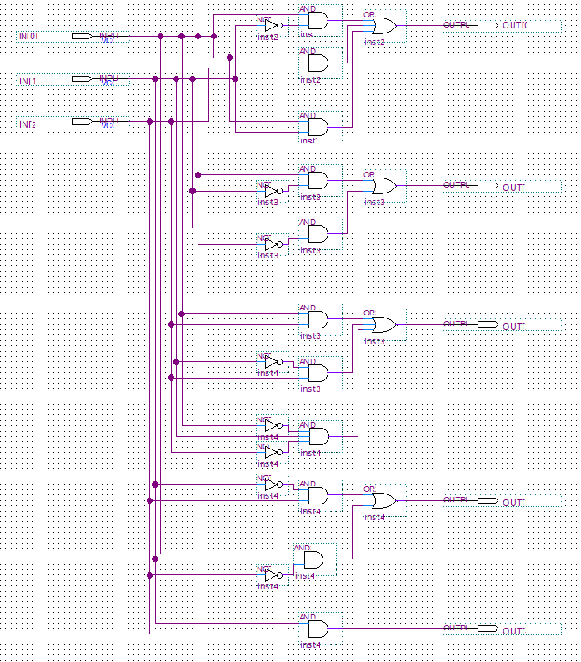



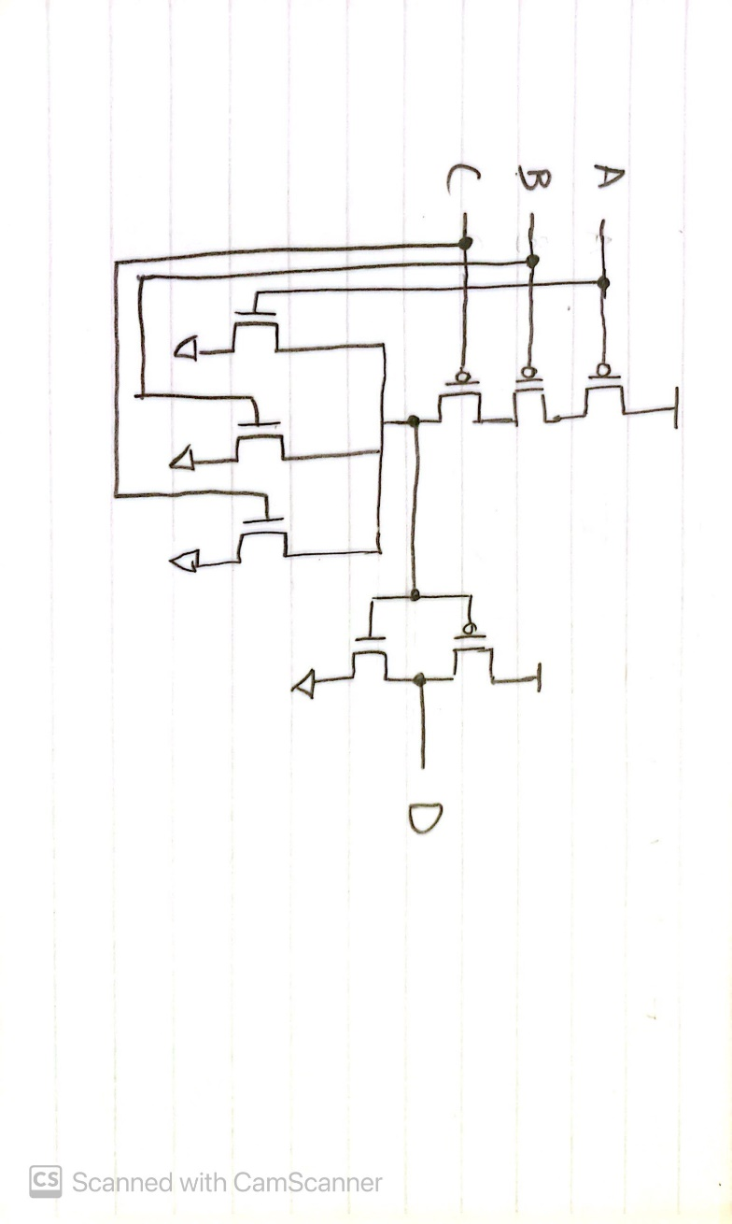

1. AB + A’B’
2. CMOS output 0 only when the output is connected to ground. We assign logic values to “low” and “high” voltage range. When there is nothing connected to the output or both voltage and ground are connected then it will output in the illegal range.